# Modifying and Testing HTML notices

In Maintenance>General>HTML Email and Slips Configurator, you can edit colours and amend headers and footers, and add your own URL links in the general Tab.

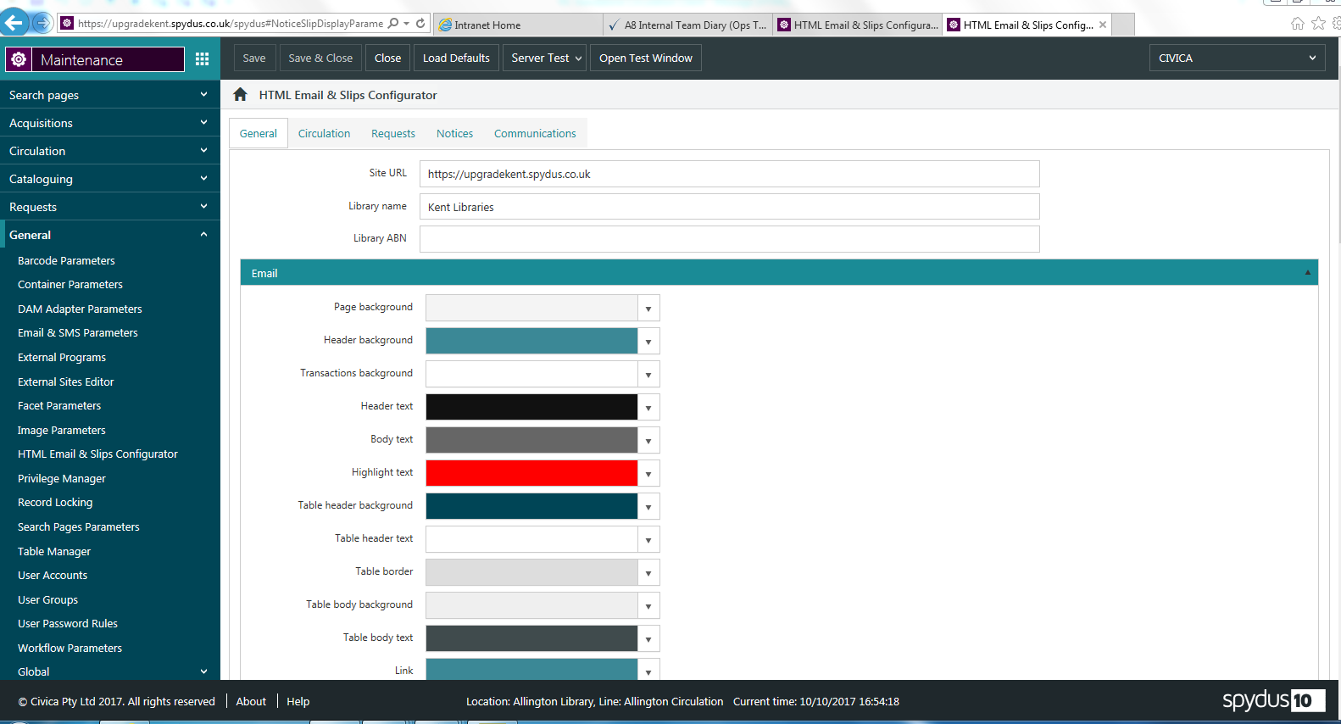

# Editing Slips

In the Circulation tab, you can further define the slips by editing each slip type for text, such as subject. These are subdivided into slips for staff ( Such as Intransit slips ), slips for Borrowers (for reservations).

You also have the type of slip listed such as Outstanding Transactions, where you can choose what transaction is to be included in the list of transactions.

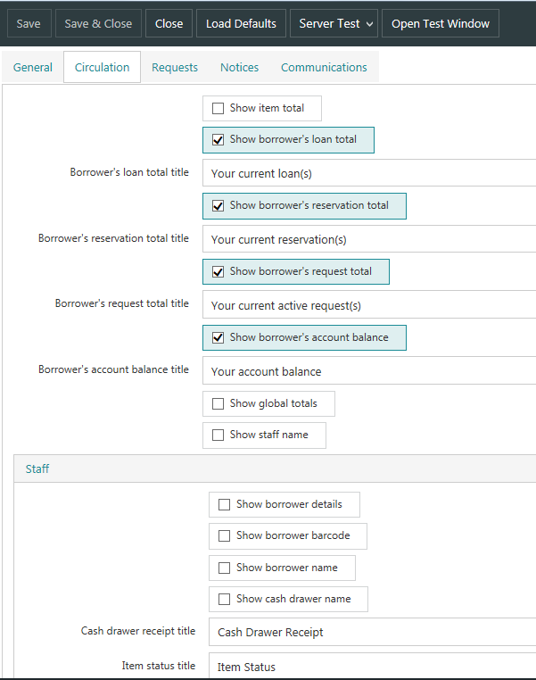

# Editing Notices

The Notices tab allows you to configure notices in more detail, such as the borrowers form of address, the wording for charges outstanding. You can then edit each notice type individually. Taking Loans Overdues as an example, for each loan type, you can configure the wording in the Header and Footer sections by selecting Edit.

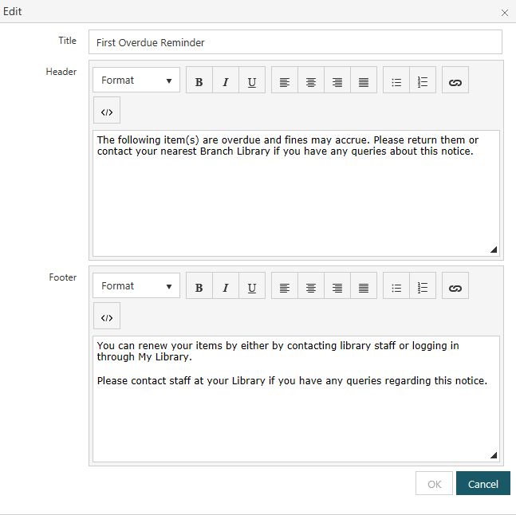

You can then test those changes in one of two ways, both of which are found by using the Server Test option at the top of the screen and selecting Notices

# Testing Notices:

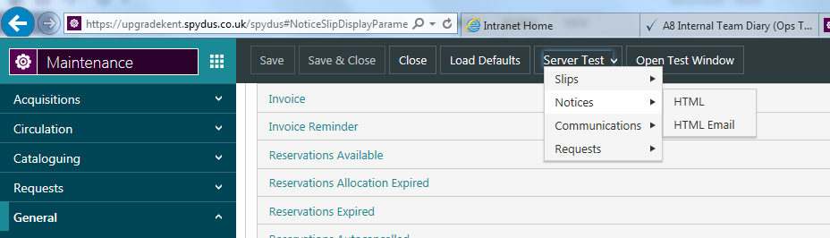

If the HTML option is selected, you select a specific type of notice to test. For example, if you want to check that the wording for the PDFs is correct, scroll down the list of reports until you reach the section . Note PDFs come quite a way down the list; email notices are first, followed by SMS, then PDFs. Select the Notice you want to test, in this case O – Overdue Loans and click on the hyperlink. This will display the PDF formatting and wording that would be generated if Notices was to run on this environment. Please note that the data canned test XML data and doesn’t come from the system you are running the notice in. This is purely a tool for testing the notice output rather than the notice task itself.

## Testing PDF Notifications

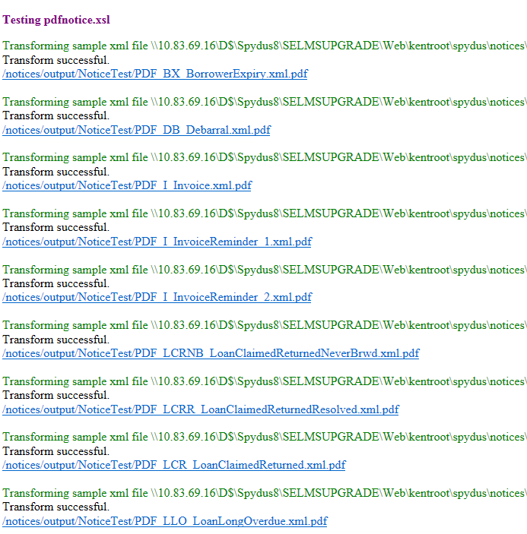

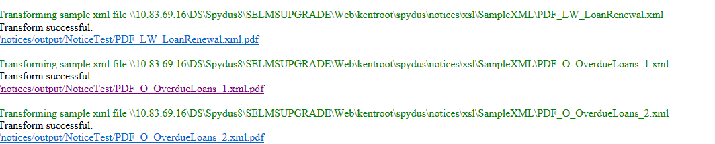

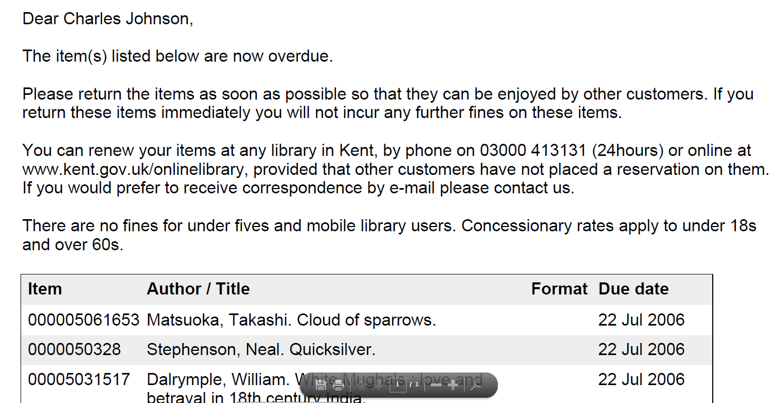

Press the Back arrow to get back to the list of Notices.

You can then select other PDF notices to test in the same way.

## Testing Email Notifications

You can test email and SMS notices in the same way, by selecting the notice under the relevant section and then clicking on the link. The email notice wording can be configured as mentioned in the notes above, the xsl notices for PDFs can’t. The wording you see on the email notices, both the title and the content is default wording and you will need to modify that wording to reflect the formats you would like to see in your own email notices.

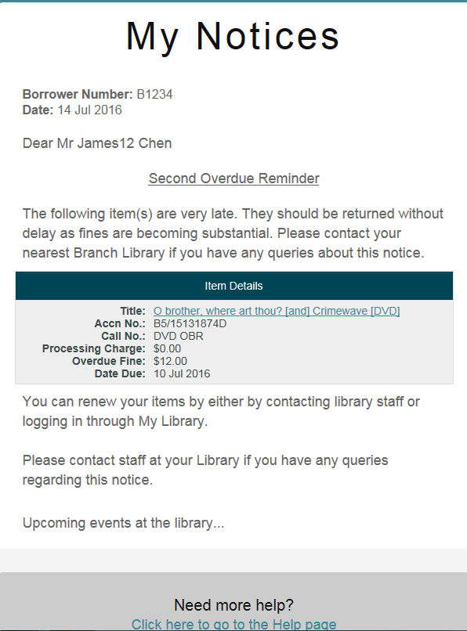

# Bulk Testing of Notices

If you don’t wish to test the email notifications one by one, you can choose to send an example of each one to yourself as an email. To do this, choose HTML Email from the Server Test>Notices drop down menu. If you put in your email address when prompted, an example of each notice will be emailed to you with the formatting and wording as currently defaulted/configured by yourselves. Again, the data in the notice is canned XML rather than current data from the system.

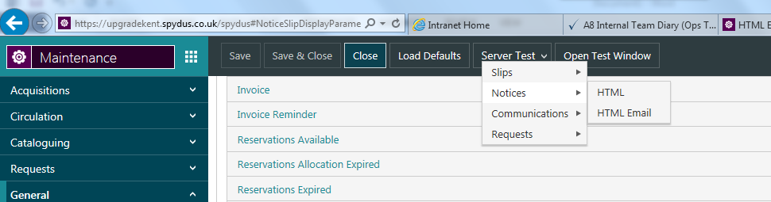

The emails will appear in your inbox like this:

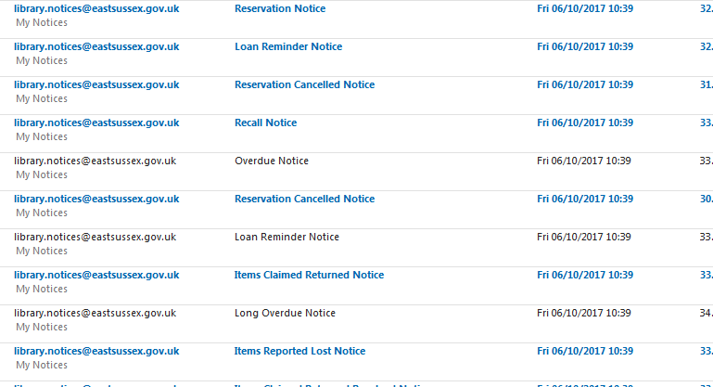

# Testing other types of Notice:

Other types of notification are classified as Communications and can be found by selecting Communications under the type of notice to test. Again, these can be tested individually or emailed to you in bulk.

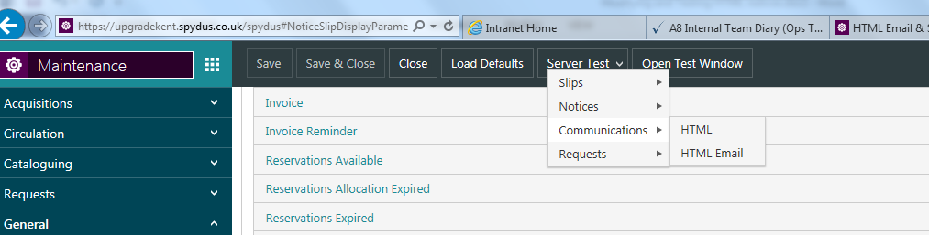

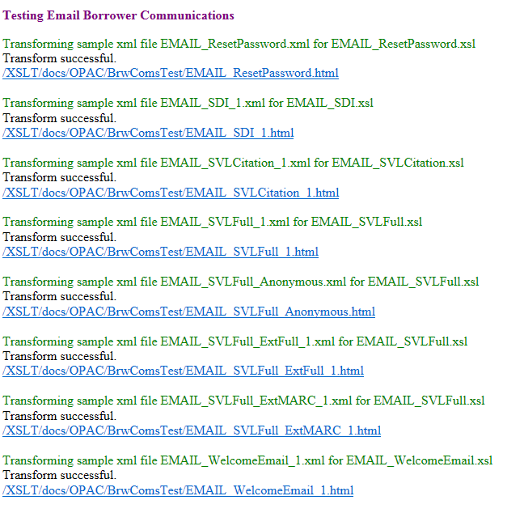

# Testing slips

Sips can be tested in exactly the same way after they have been configured, for both emailed slips and printed slips. Email slips appear first in the list if you select HTML as the option.Again, canned data is used.

